PIZZA SALES ANALYSIS(SQL)

1.Total number of orders placed.
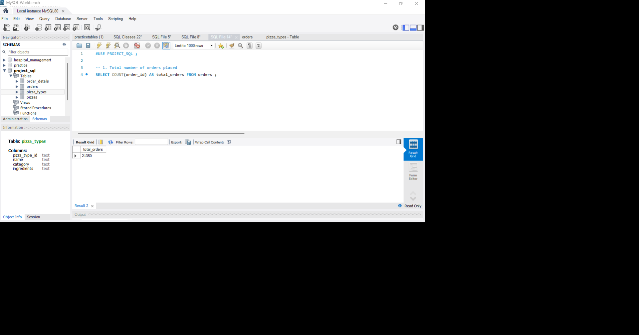
Objective: This section provides an analysis of the total transaction volume
processed by the business. Total orders =21350

Syntax: SELECT COUNT(order_id) AS total_orders FROM orders;
2. Total revenue generated from pizza sales.
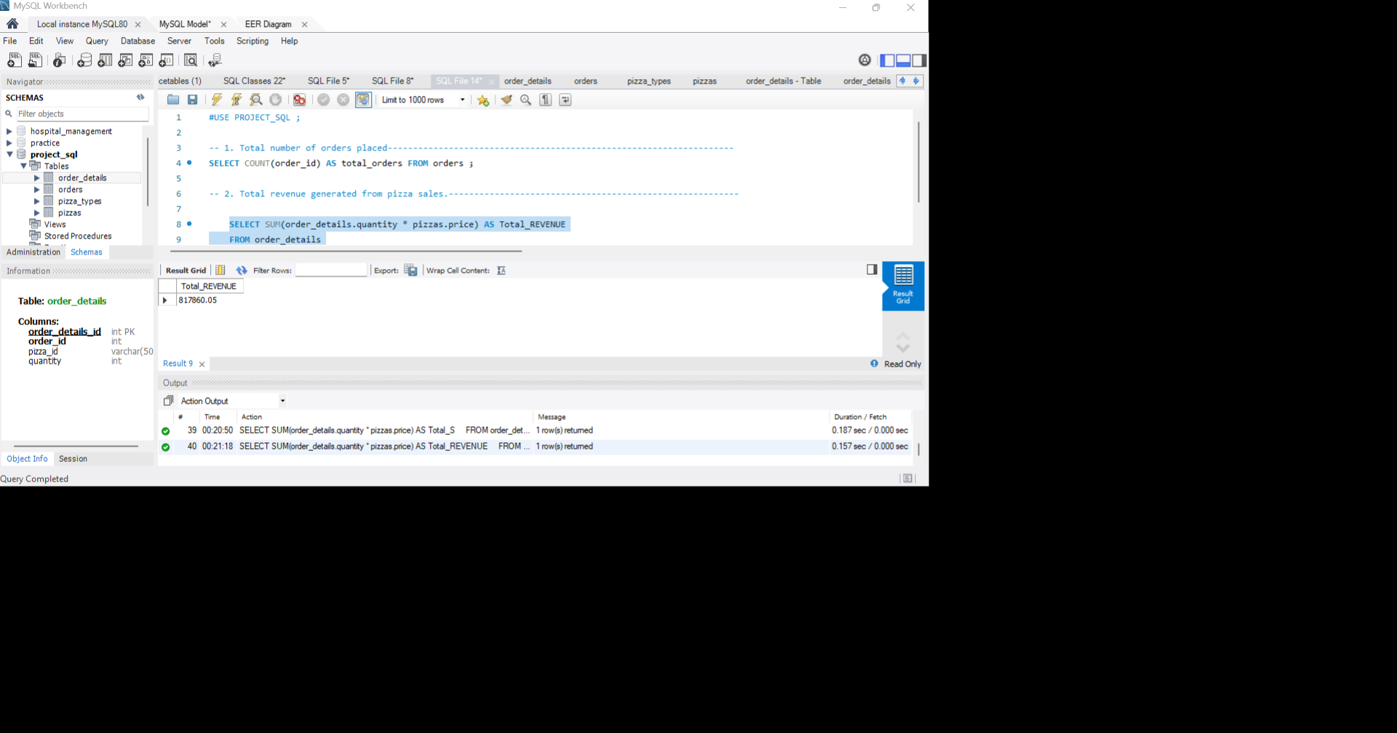
Objective: This is the analysis of the total gross revenue generated from
all pizza sales. This metric represents raw consumer spending.
TOTAL REVENUE =817860 Rupees.
TOTAL QUANTITY OF PIZZAS SOLD = 49574.
TOTAL PRICE= 1578.30 Rupees.

Syntax: SELECT SUM(order_details.quantity * pizzas.price) AS Total_REVENUE
FROM order_details JOIN pizzas ON pizzas.pizza_id = order_details.pizza_id;
3. Top 5 Highest Priced Pizza.
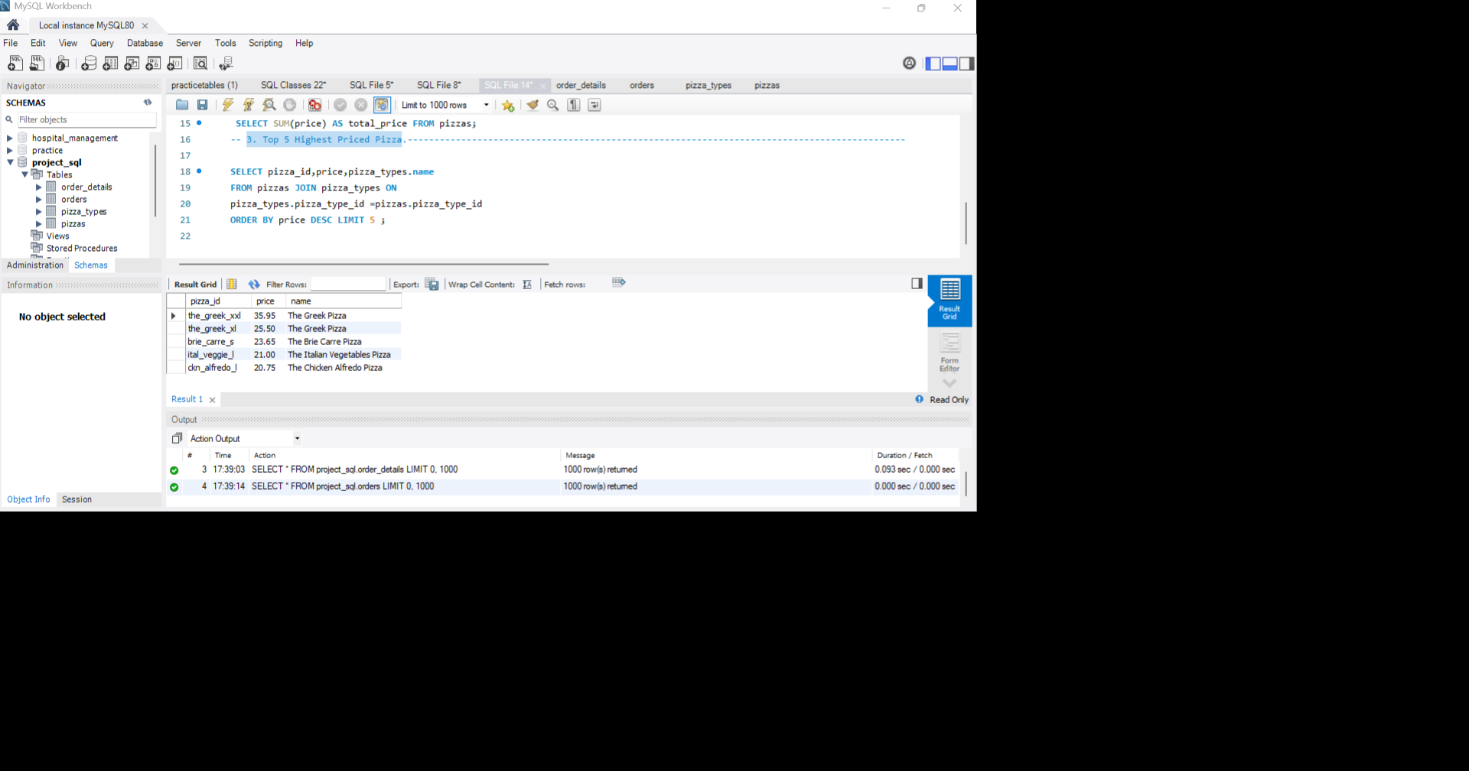
Objective: The primary business purpose of this query is to
identify the premium segment of the menu. Pinpointing the
highest-priced pizza in the menu. It helps management to analyse the
pricing strategies, evaluate profit margins, and track premium
product performance.
MOST PREMIUM PRODUCT(PIZZA)= THE GREEK PIZZA
PRICE=35.95 RUPEE. PRODUCT ID =”the_Greek_xxl”.
Syntax: SELECT pizza_id,price,pizza_types.name FROM pizzas JOIN pizza_types ON
pizza_types.pizza_type_id =pizzas.pizza_type_id ORDER BY price DESC LIMIT 5 ;

4. Most Common Pizza Size Ordered.
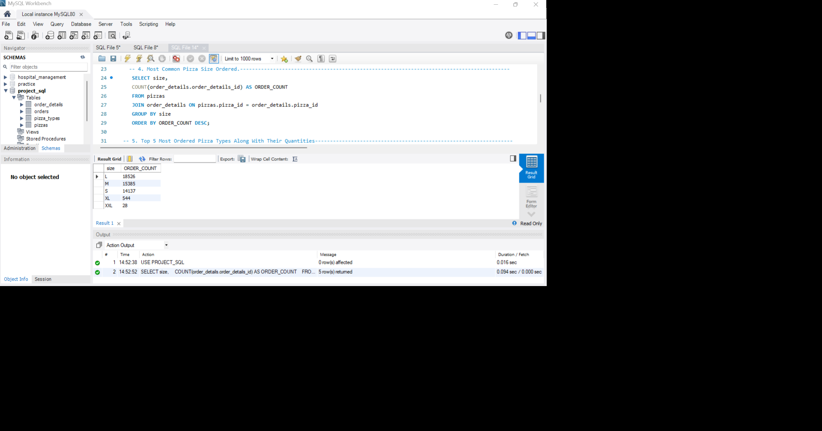
Objective: This SQL query identifies the most popular pizza size based on the
order volume.
“L “is the most popular pizza size. Ordered 18526 times.
2nd most popular pizza size is “M”. Ordered 15385 times.
3rd most popular pizza size is “S”. Ordered 14137 times.
Syntax: SELECT size, COUNT(order_details.order_details_id) AS ORDER_COUNT
FROM pizzas JOIN order_details ON pizzas.pizza_id = order_details.pizza_id GROUP BY size ORDER BY ORDER_COUNT DESC;
5. Top 5 Most Ordered Pizza Types Along with Their Quantities
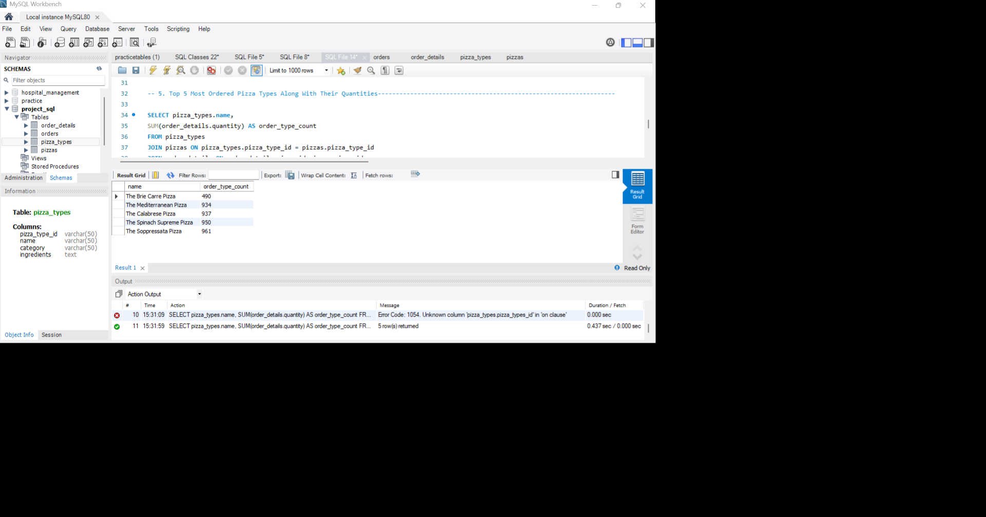
Objective: This query identifies the top 5 least popular pizzas based
on the total quantity ordered. This analysis helps businesses to understand
their menu and highlights the potential modification to grow the business.
Most ordered pizza type is “The soppressata pizza”.
Count of order = 961
Syntax: SELECT pizza_types.name,
SUM(order_details.quantity) AS order_type_count
FROM pizza_types
JOIN pizzas ON pizza_types.pizza_type_id = pizzas.pizza_type_id
JOIN order_details ON order_details.pizza_id=pizzas.pizza_id
GROUP BY pizza_types.name
ORDER BY order_type_count LIMIT 5 ;
6. Total Quantity Of Each Pizza Category Ordered.
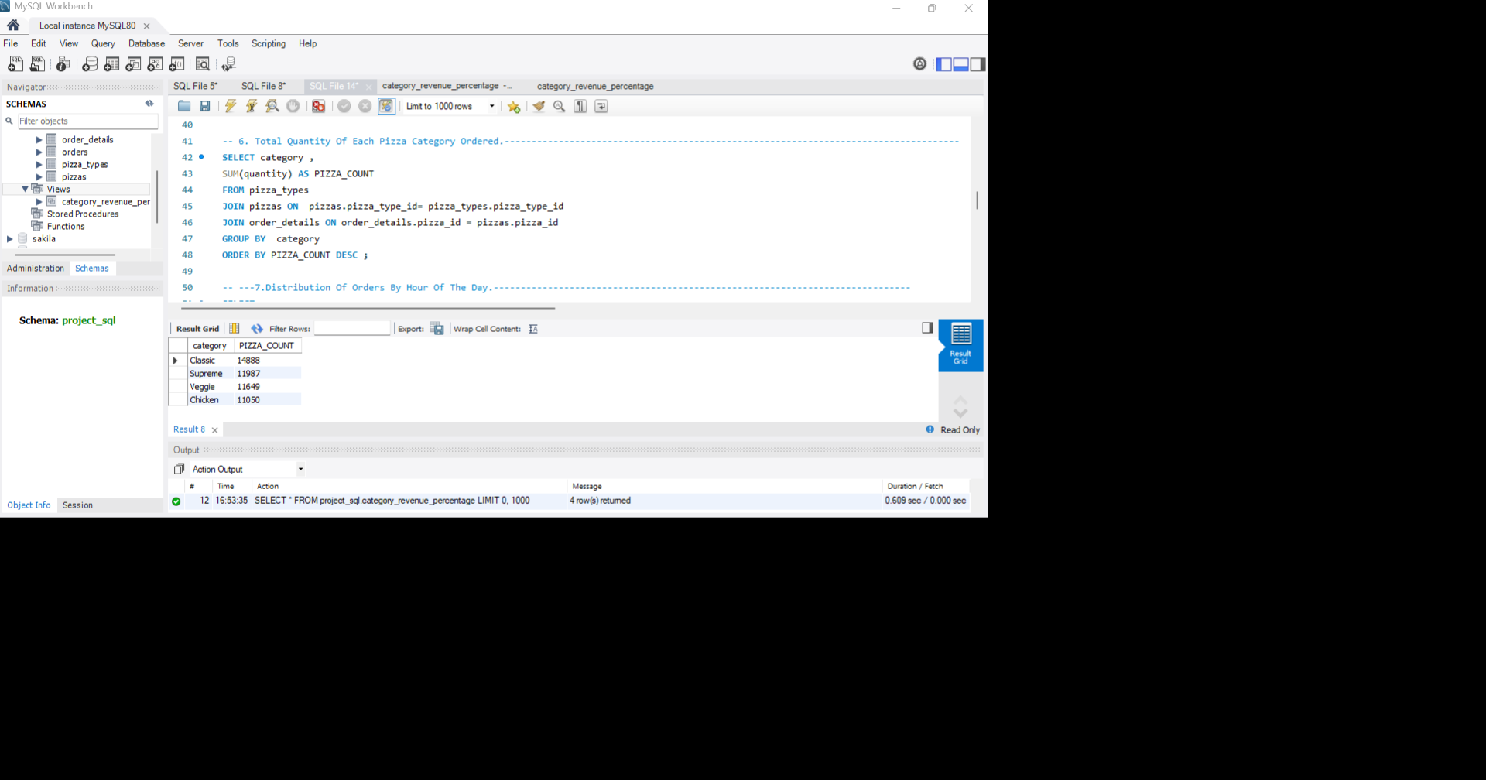
Objective: The query calculates the total quantity of pizzas sold for each pizza category by summing the ordered quantities from the order_details table. It joins the pizza_types, pizzas, and order_details tables to map each order to its respective category, groups the results by category, and ranks them in descending order. For example, Classic recorded approximately 14,888 pizzas sold, followed by Supreme (11,987), Chicken (11,050), and Veggie (11,049), highlighting that the Classic category had the highest customer demand.
Syntax: SELECT category ,
SUM(quantity) AS PIZZA_COUNT
FROM pizza_types
JOIN pizzas ON pizzas.pizza_type_id= pizza_types.pizza_type_id
JOIN order_details ON order_details.pizza_id = pizzas.pizza_id
GROUP BY category
ORDER BY PIZZA_COUNT DESC ;
7.Distribution Of Orders By Hour Of The Day.
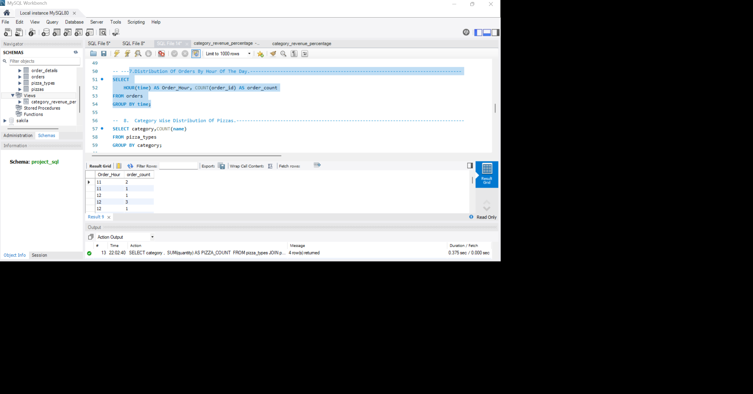
Objective: This query calculates the total number of orders placed during
each hour of the day by extracting the hour from the order time and
counting the orders. For example, if 1,480 orders were placed at 6:00 PM
(18:00) compared to 320 orders at 10:00 AM (10:00), it indicates that 6:00 PM
is a peak ordering hour.

Syntax: SELECT HOUR(time) AS Order_Hour, COUNT(order_id) AS order_count
FROM orders GROUP BY time;
8. Category Wise Distribution Of Pizzas
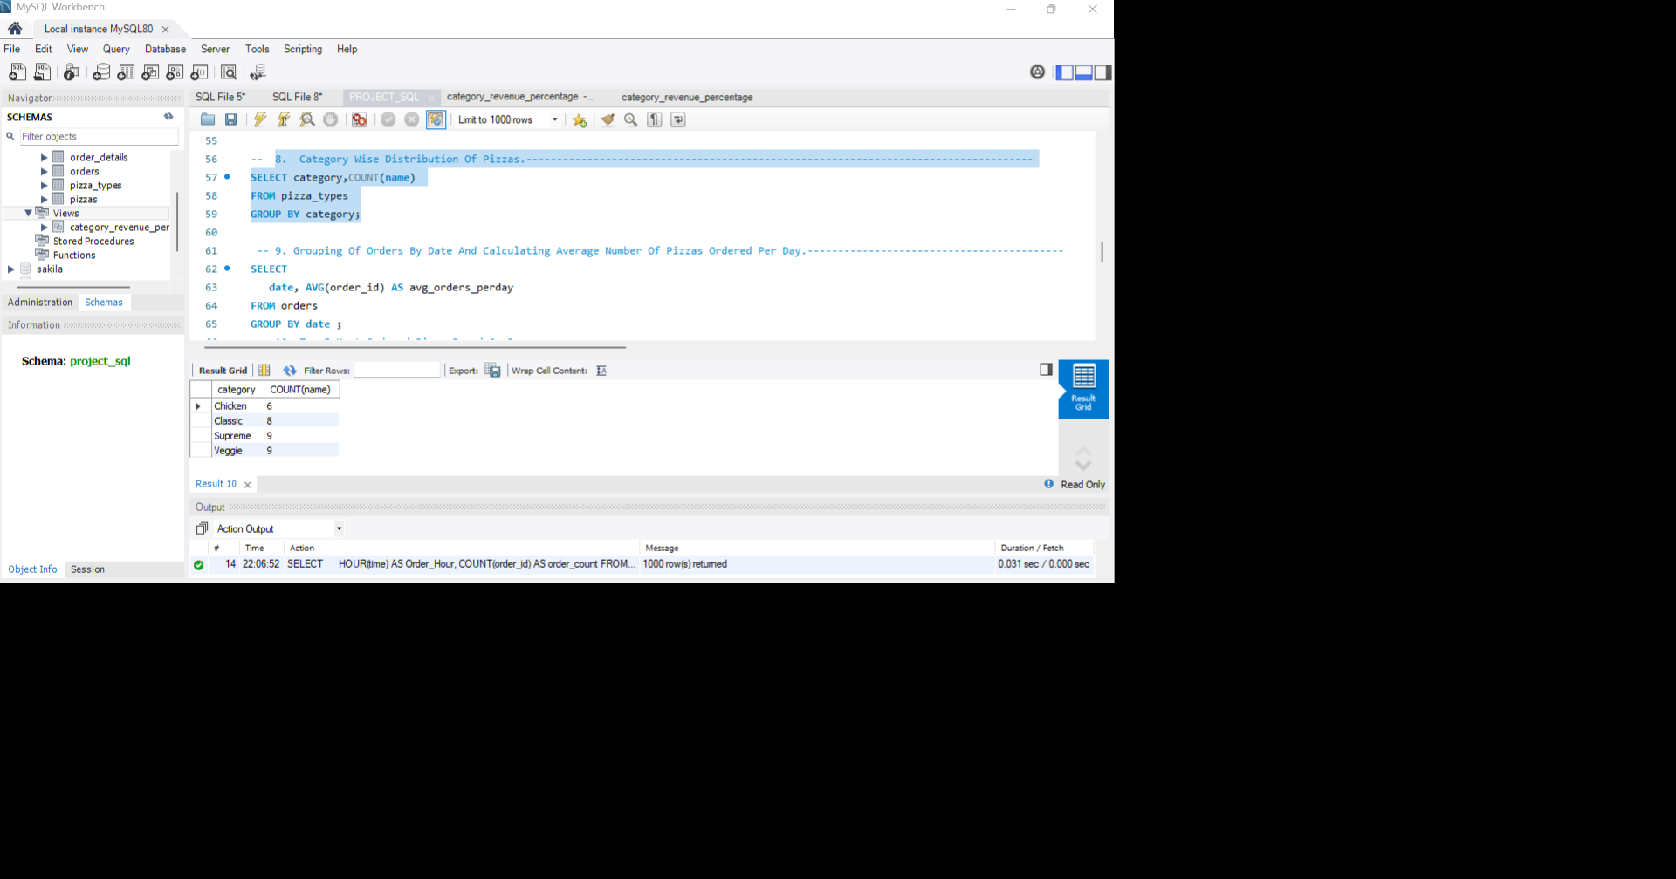
Objective: Category-wise Distribution of Pizzas:
The menu offers 32 pizza varieties across 4 categories: Classic (8), Supreme
(9), Veggie (9), and Chicken (6). Supreme and Veggie have the widest variety,
while Chicken has the fewest pizza options.
Syntax: SELECT category,COUNT(name) FROM pizza_types GROUP BY category;

